Test Case: tc002_SPX_Dev5_Crear_Requisicion_Spot_Con_FAD_Tipo_Cobro_CC
Step 1 - Enter username and password and click to button Enter : Credentials Entered
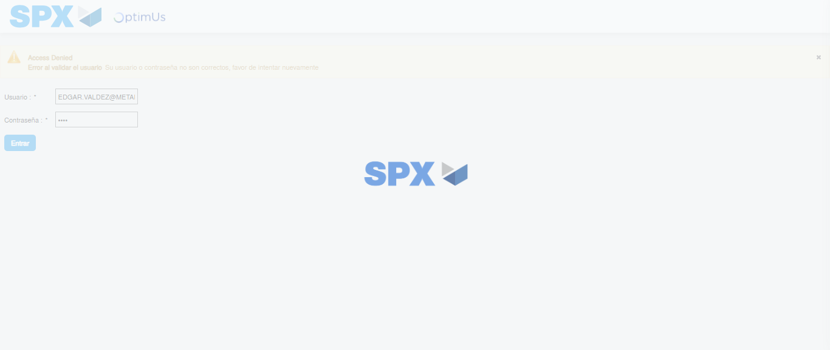Image file-name: QC_Testing-tc002_SPX_Dev5_Crear_Requisicion_Spot_Con_FAD_Tipo_Cobro_CC-1781656340672

Step 2 - Select to UEN and Access to Spot Buy Requisitions : UEN Correctly selected and Correct access
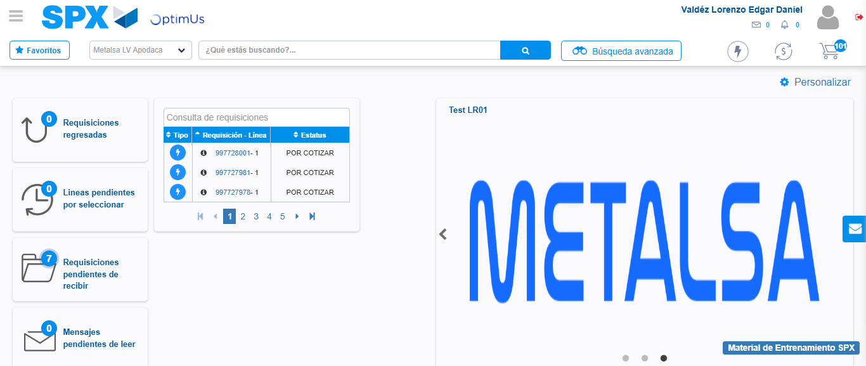Image file-name: QC_Testing-tc002_SPX_Dev5_Crear_Requisicion_Spot_Con_FAD_Tipo_Cobro_CC-1781656366537

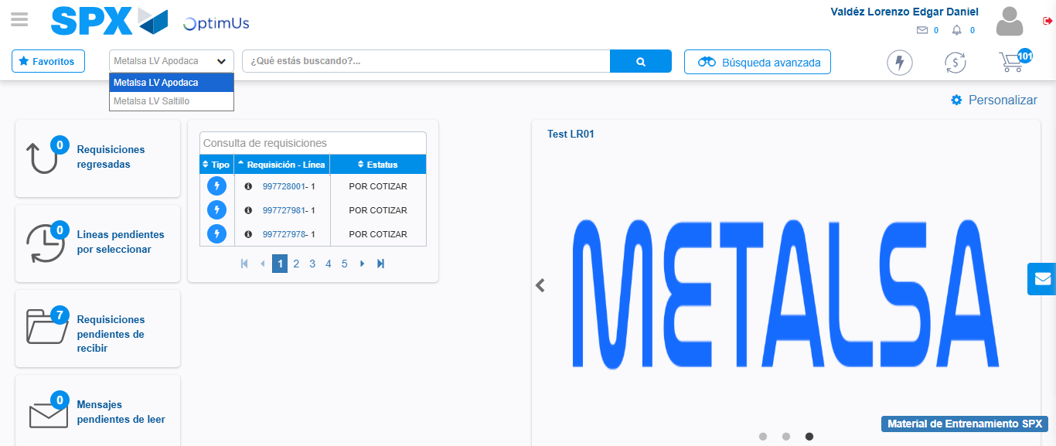Image file-name: QC_Testing-tc002_SPX_Dev5_Crear_Requisicion_Spot_Con_FAD_Tipo_Cobro_CC-1781656369105

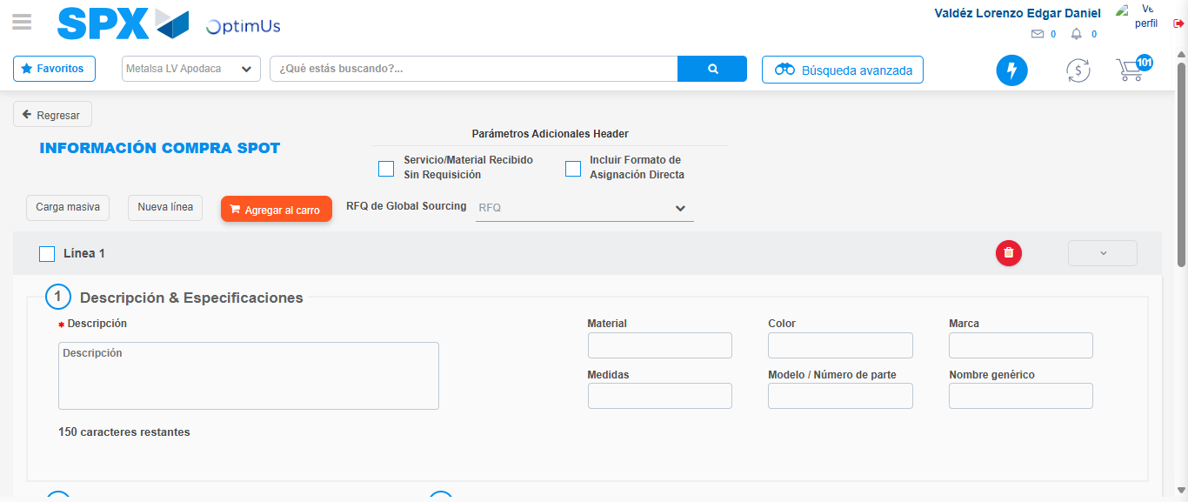Image file-name: QC_Testing-tc002_SPX_Dev5_Crear_Requisicion_Spot_Con_FAD_Tipo_Cobro_CC-1781656416486

Step 3 - Add FAD to Requisition: FAD Successfully Added
Image file-name: QC_Testing-tc002_SPX_Dev5_Crear_Requisicion_Spot_Con_FAD_Tipo_Cobro_CC-1781656416720

Image file-name: QC_Testing-tc002_SPX_Dev5_Crear_Requisicion_Spot_Con_FAD_Tipo_Cobro_CC-1781656416906

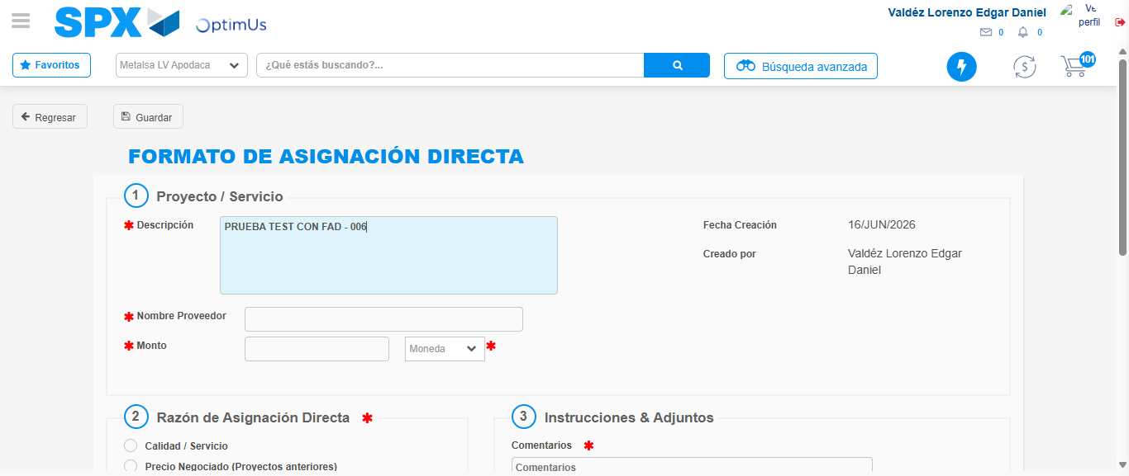Image file-name: QC_Testing-tc002_SPX_Dev5_Crear_Requisicion_Spot_Con_FAD_Tipo_Cobro_CC-1781656419547

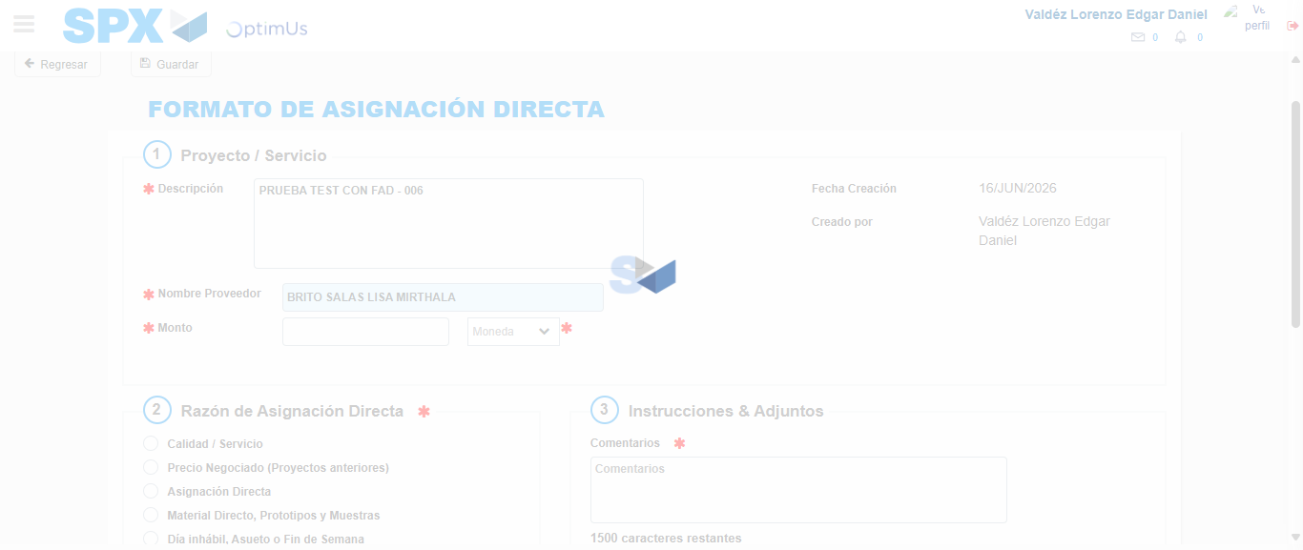Image file-name: QC_Testing-tc002_SPX_Dev5_Crear_Requisicion_Spot_Con_FAD_Tipo_Cobro_CC-1781656424925

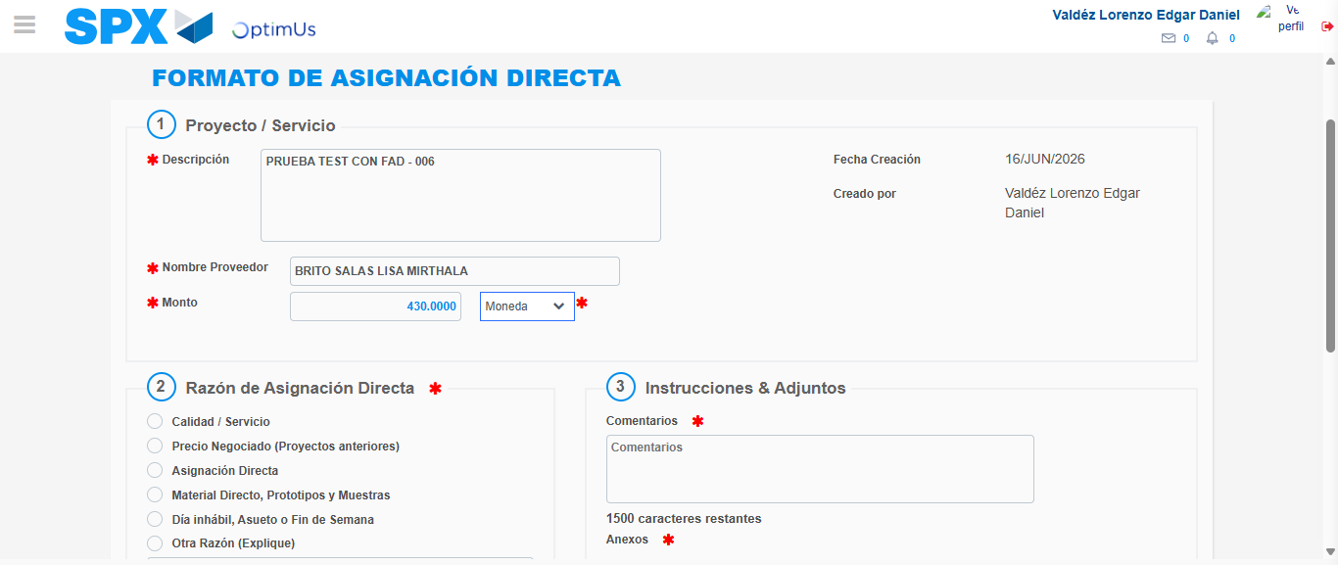Image file-name: QC_Testing-tc002_SPX_Dev5_Crear_Requisicion_Spot_Con_FAD_Tipo_Cobro_CC-1781656425349

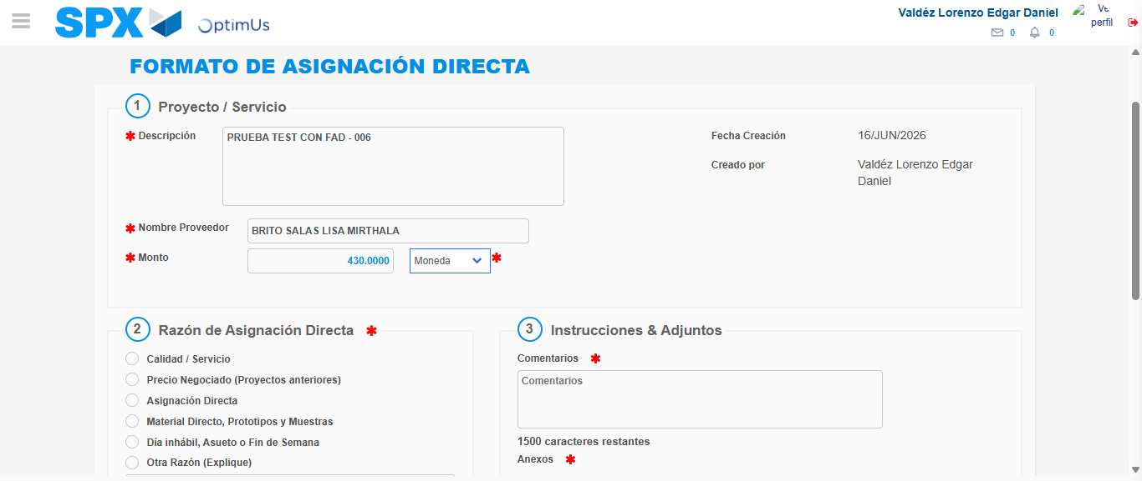Image file-name: QC_Testing-tc002_SPX_Dev5_Crear_Requisicion_Spot_Con_FAD_Tipo_Cobro_CC-1781656425545

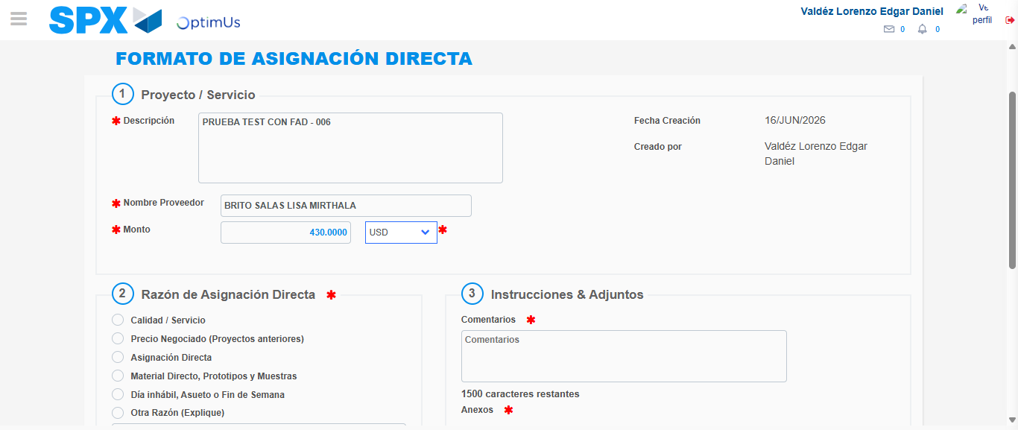Image file-name: QC_Testing-tc002_SPX_Dev5_Crear_Requisicion_Spot_Con_FAD_Tipo_Cobro_CC-1781656425897

Image file-name: QC_Testing-tc002_SPX_Dev5_Crear_Requisicion_Spot_Con_FAD_Tipo_Cobro_CC-1781656426069

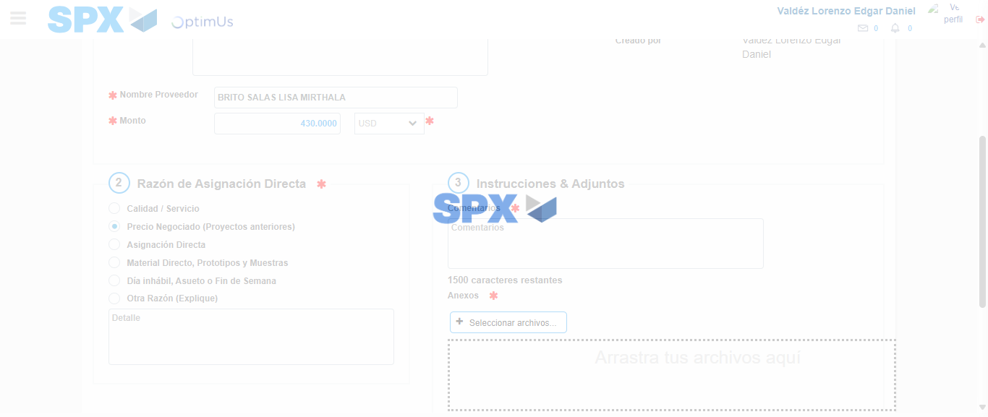Image file-name: QC_Testing-tc002_SPX_Dev5_Crear_Requisicion_Spot_Con_FAD_Tipo_Cobro_CC-1781656426913

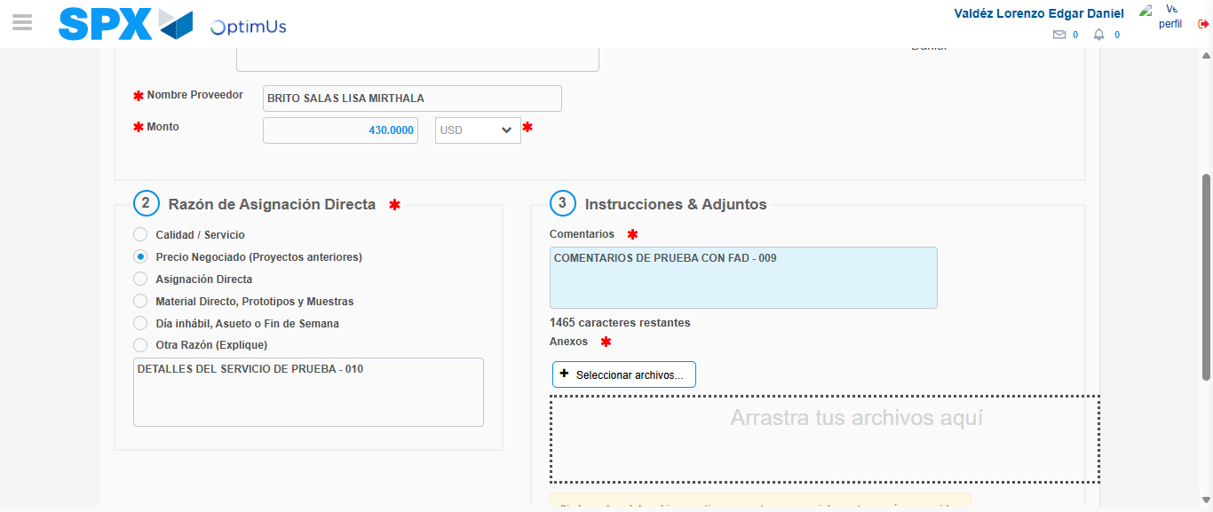Image file-name: QC_Testing-tc002_SPX_Dev5_Crear_Requisicion_Spot_Con_FAD_Tipo_Cobro_CC-1781656437801

Image file-name: QC_Testing-tc002_SPX_Dev5_Crear_Requisicion_Spot_Con_FAD_Tipo_Cobro_CC-1781656438498

Step 4 - Data Capture Spot Buy Requisition: Data captured correctly
Image file-name: QC_Testing-tc002_SPX_Dev5_Crear_Requisicion_Spot_Con_FAD_Tipo_Cobro_CC-1781656416720

Image file-name: QC_Testing-tc002_SPX_Dev5_Crear_Requisicion_Spot_Con_FAD_Tipo_Cobro_CC-1781656416906

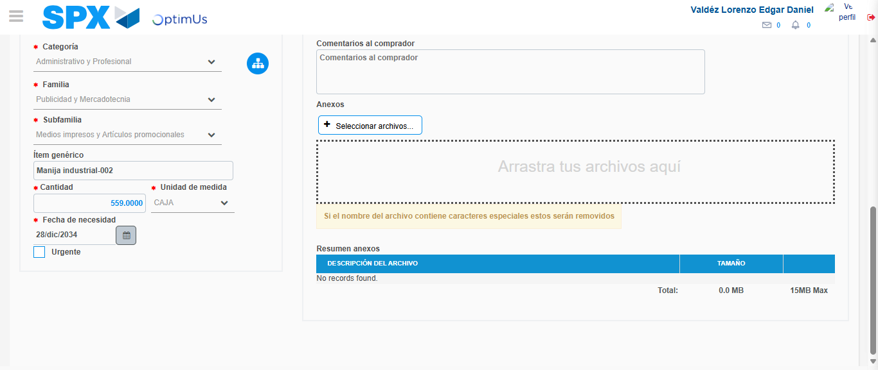Image file-name: QC_Testing-tc002_SPX_Dev5_Crear_Requisicion_Spot_Con_FAD_Tipo_Cobro_CC-1781656471404

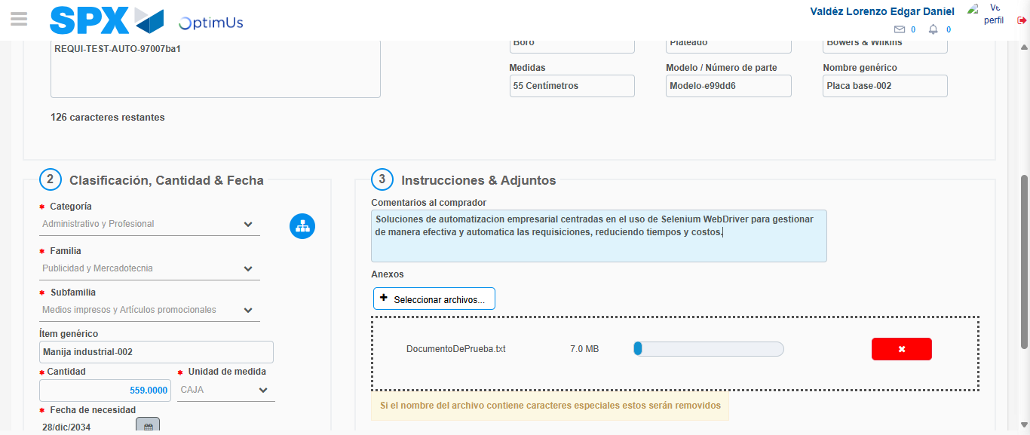Image file-name: QC_Testing-tc002_SPX_Dev5_Crear_Requisicion_Spot_Con_FAD_Tipo_Cobro_CC-1781656472166

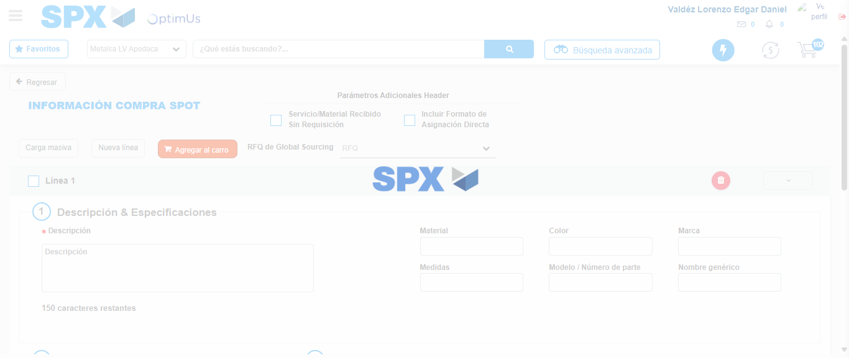Image file-name: QC_Testing-tc002_SPX_Dev5_Crear_Requisicion_Spot_Con_FAD_Tipo_Cobro_CC-1781656476654

Step 5 - Select to Requisition: Requisition Correctly selected
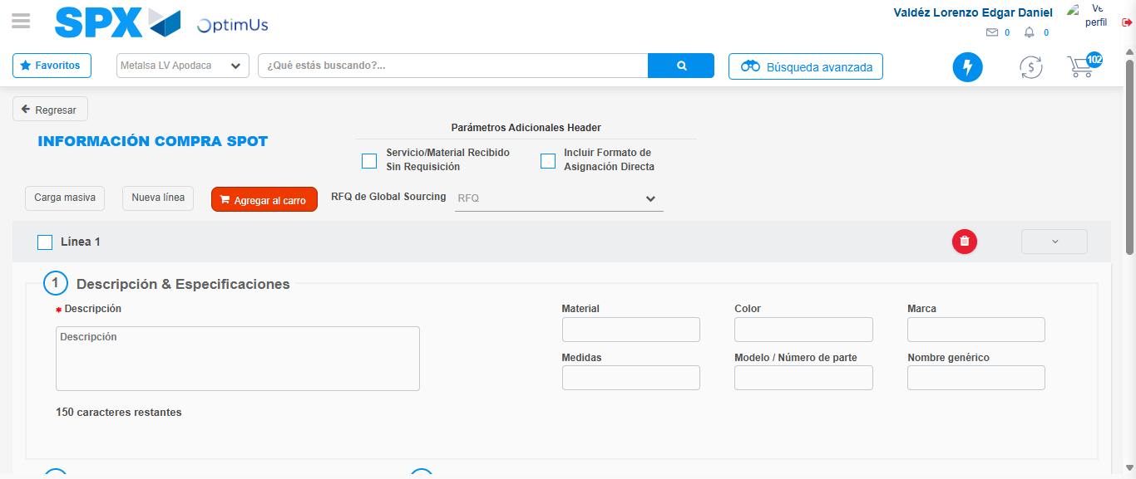Image file-name: QC_Testing-tc002_SPX_Dev5_Crear_Requisicion_Spot_Con_FAD_Tipo_Cobro_CC-1781656476847

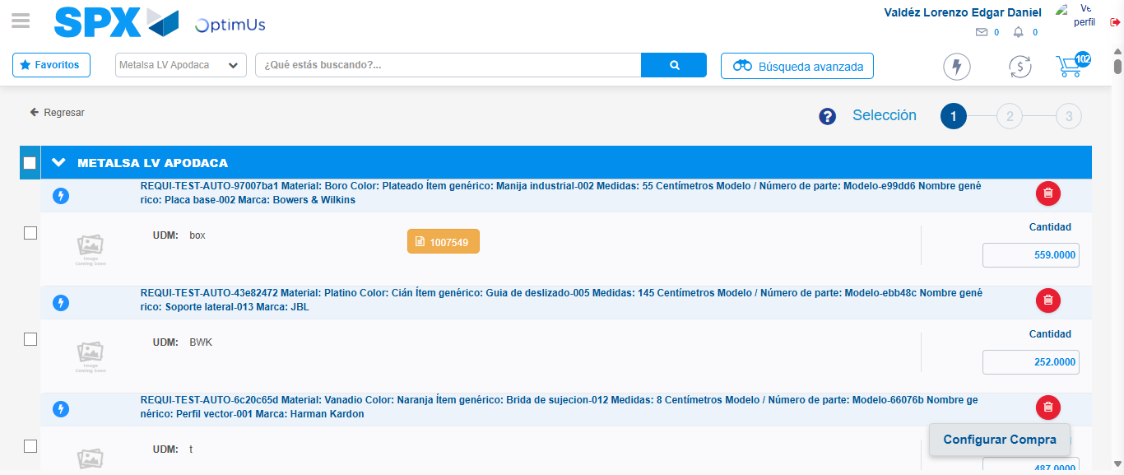Image file-name: QC_Testing-tc002_SPX_Dev5_Crear_Requisicion_Spot_Con_FAD_Tipo_Cobro_CC-1781656489274

Image file-name: QC_Testing-tc002_SPX_Dev5_Crear_Requisicion_Spot_Con_FAD_Tipo_Cobro_CC-1781656489538

Image file-name: QC_Testing-tc002_SPX_Dev5_Crear_Requisicion_Spot_Con_FAD_Tipo_Cobro_CC-1781656489742

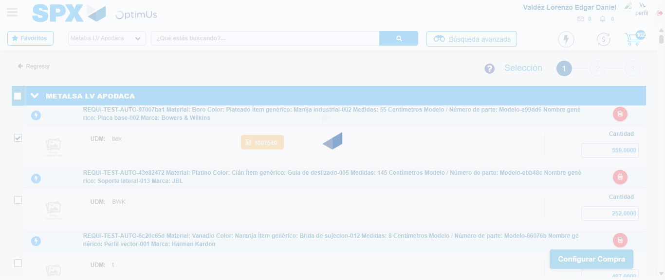Image file-name: QC_Testing-tc002_SPX_Dev5_Crear_Requisicion_Spot_Con_FAD_Tipo_Cobro_CC-1781656490636

Step 6 - Select Type Account For Requisition: Type Account Correctly selected
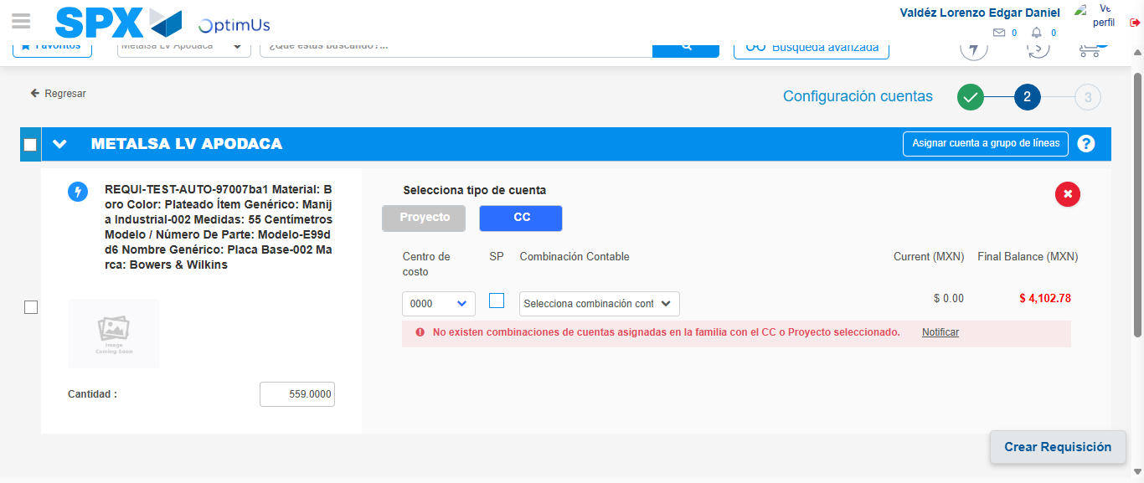Image file-name: QC_Testing-tc002_SPX_Dev5_Crear_Requisicion_Spot_Con_FAD_Tipo_Cobro_CC-1781656515079

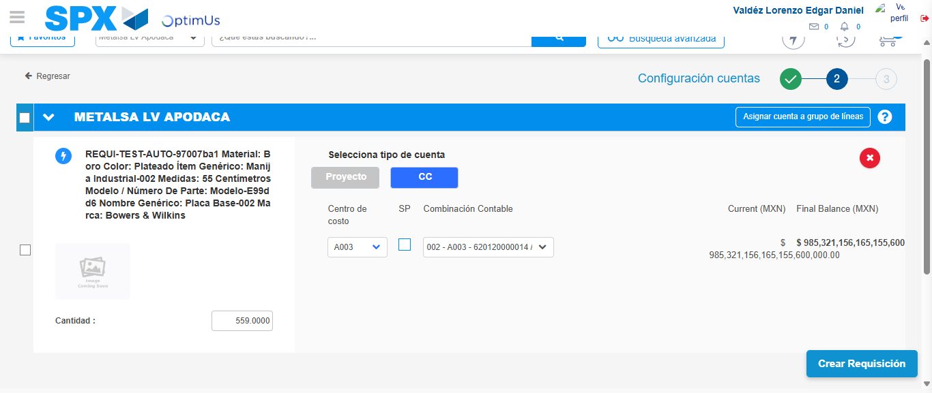Image file-name: QC_Testing-tc002_SPX_Dev5_Crear_Requisicion_Spot_Con_FAD_Tipo_Cobro_CC-1781656523012

Image file-name: QC_Testing-tc002_SPX_Dev5_Crear_Requisicion_Spot_Con_FAD_Tipo_Cobro_CC-1781656523197

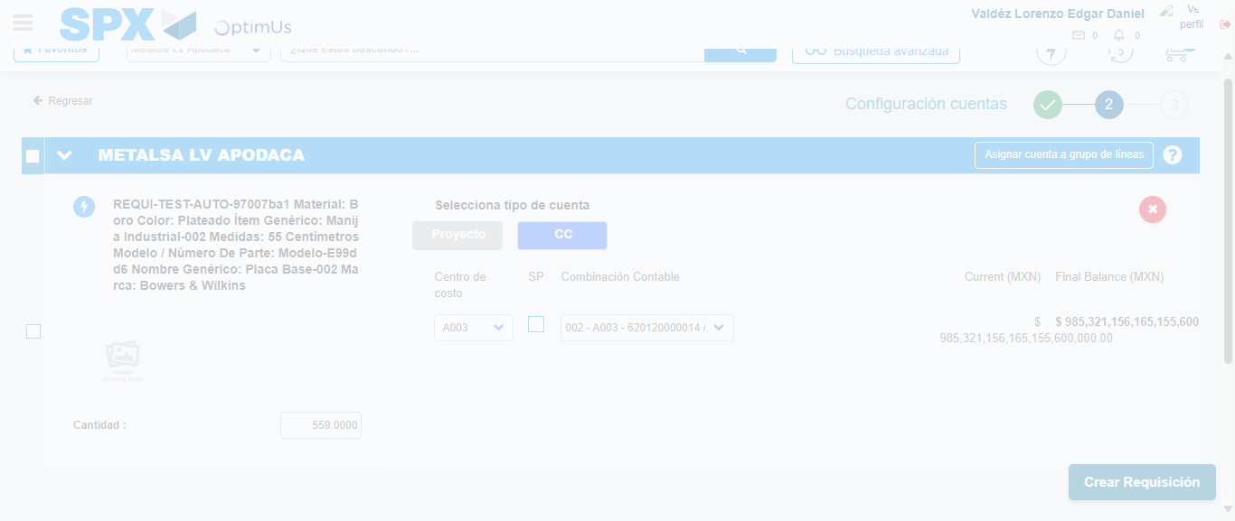Image file-name: QC_Testing-tc002_SPX_Dev5_Crear_Requisicion_Spot_Con_FAD_Tipo_Cobro_CC-1781656523556

Step 7 - Accept to Requisition: Requisition Accepted
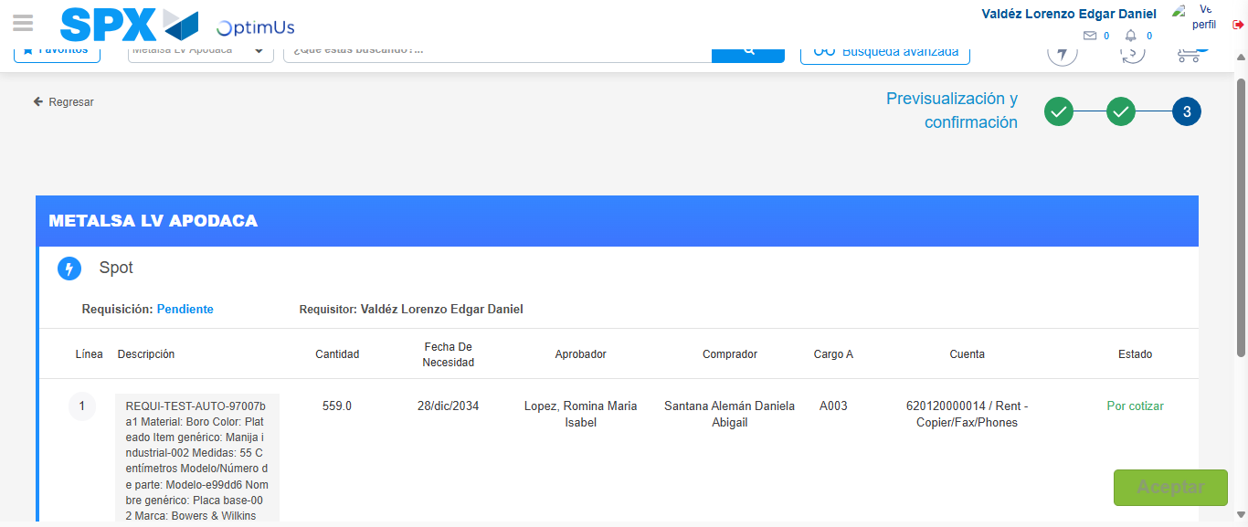Image file-name: QC_Testing-tc002_SPX_Dev5_Crear_Requisicion_Spot_Con_FAD_Tipo_Cobro_CC-1781656524372

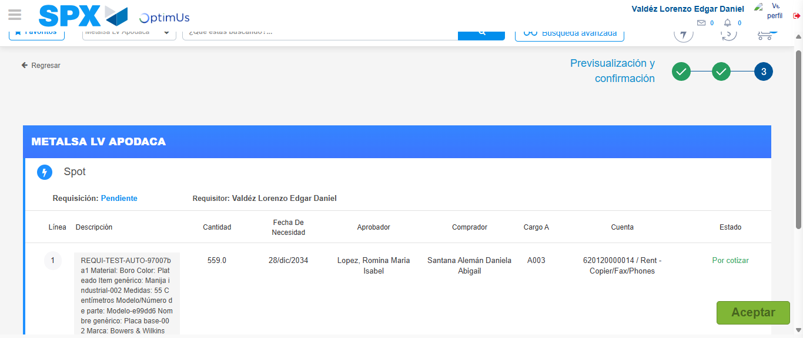Image file-name: QC_Testing-tc002_SPX_Dev5_Crear_Requisicion_Spot_Con_FAD_Tipo_Cobro_CC-1781656524602

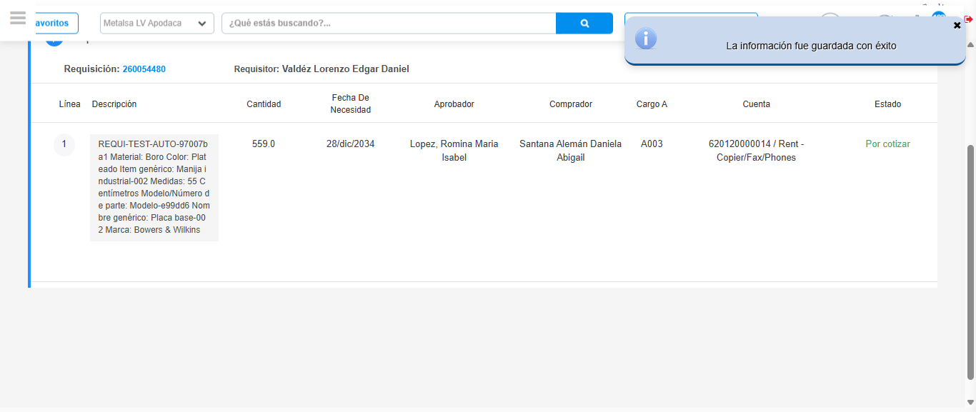Image file-name: QC_Testing-tc002_SPX_Dev5_Crear_Requisicion_Spot_Con_FAD_Tipo_Cobro_CC-1781656527521

Step 8 - Return to Main Page SPX : Return to Main Page SPX
Image file-name: QC_Testing-tc002_SPX_Dev5_Crear_Requisicion_Spot_Con_FAD_Tipo_Cobro_CC-1781656366537

Image file-name: QC_Testing-tc002_SPX_Dev5_Crear_Requisicion_Spot_Con_FAD_Tipo_Cobro_CC-1781656369105

Image file-name: QC_Testing-tc002_SPX_Dev5_Crear_Requisicion_Spot_Con_FAD_Tipo_Cobro_CC-1781656416486

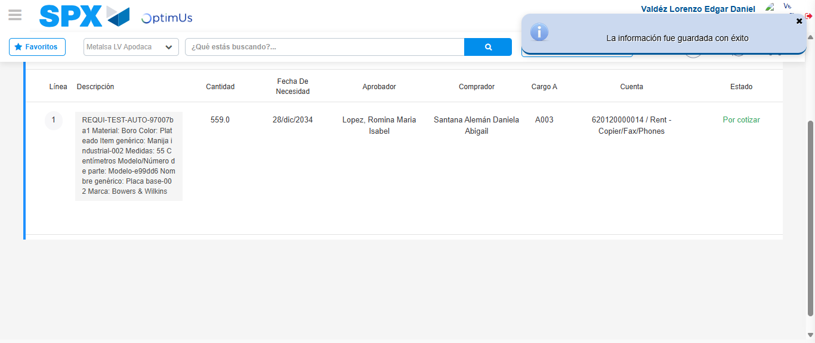Image file-name: QC_Testing-tc002_SPX_Dev5_Crear_Requisicion_Spot_Con_FAD_Tipo_Cobro_CC-1781656529718

Image file-name: QC_Testing-tc002_SPX_Dev5_Crear_Requisicion_Spot_Con_FAD_Tipo_Cobro_CC-1781656529878

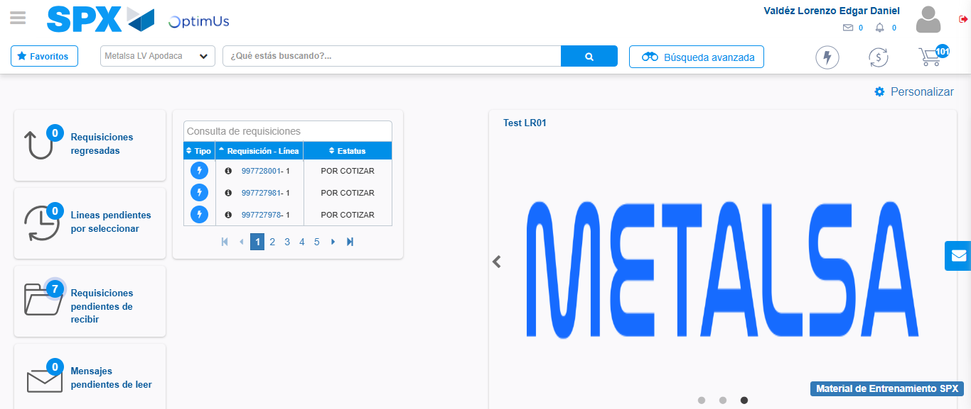Image file-name: QC_Testing-tc002_SPX_Dev5_Crear_Requisicion_Spot_Con_FAD_Tipo_Cobro_CC-1781656550892

Step 9 - Log Out : Log Out SPX
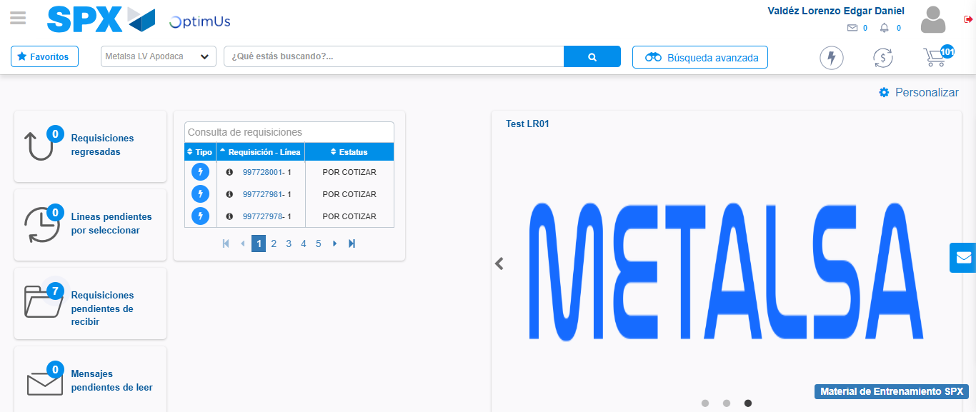Image file-name: QC_Testing-tc002_SPX_Dev5_Crear_Requisicion_Spot_Con_FAD_Tipo_Cobro_CC-1781656551151

